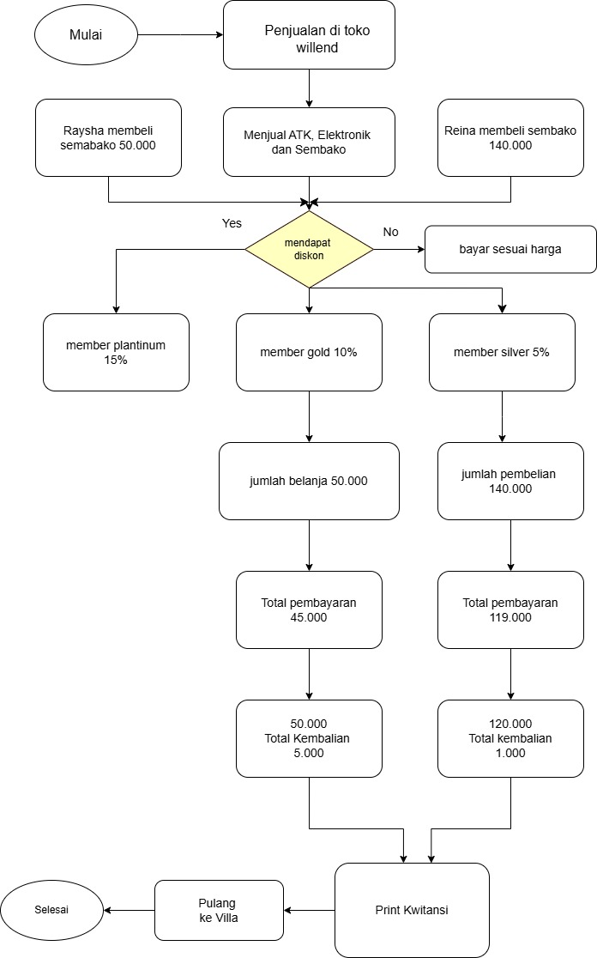**Flowchart Toko willend_d is the name syawal**